**ASSIGNMENT-25.4:**

A table named travel is created with the given columns. Then the data is loaded and displayed using the select command.

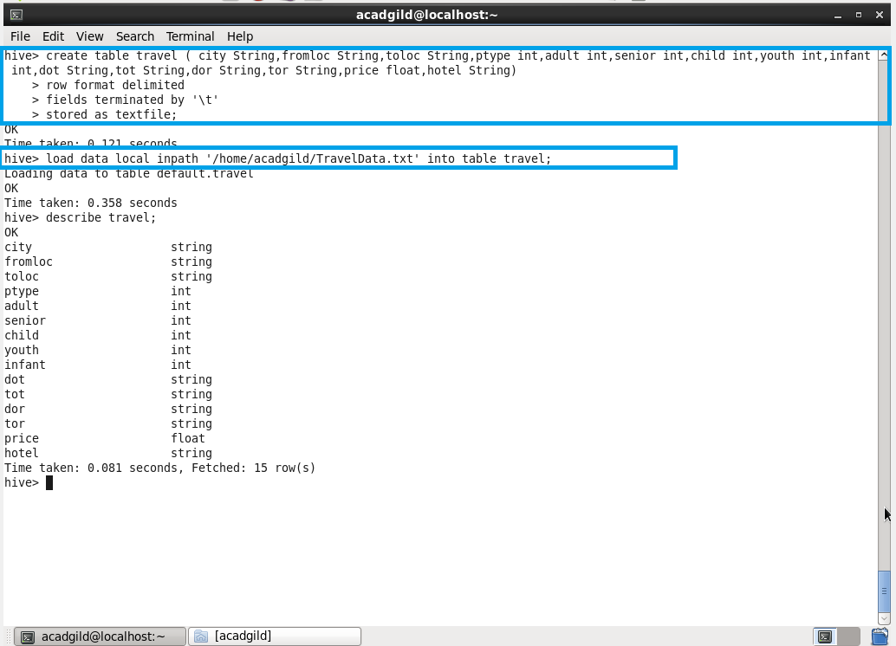

QUESTION 1 : Write a hive query to find the top 20 destination people travel the most based on the given data :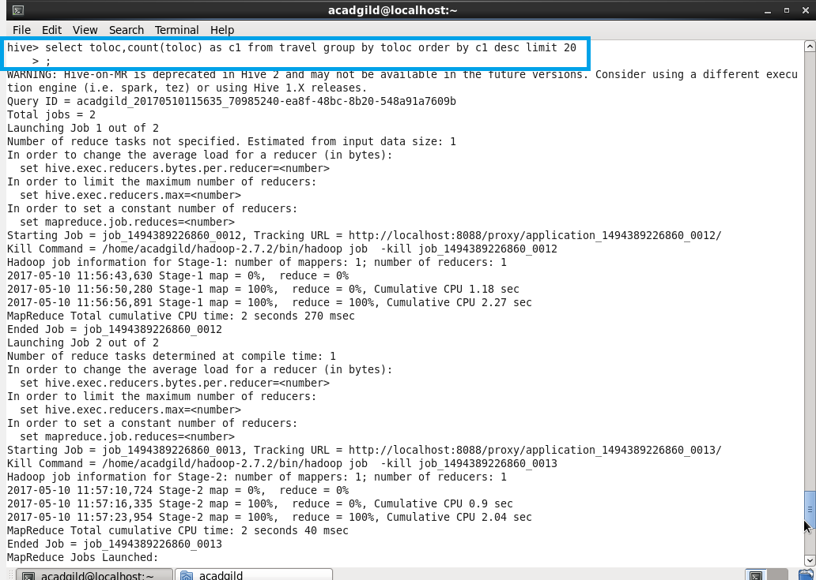

OUTPUT :

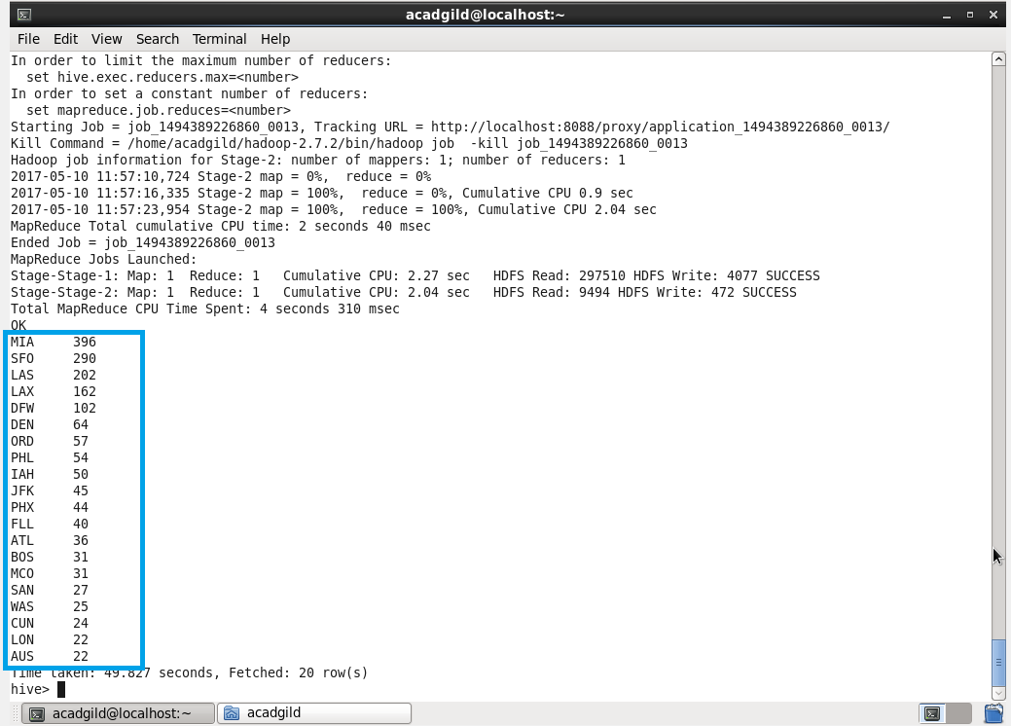

QUESTION 2 : Write a hive query to find the top 20 locations from where people travel the most

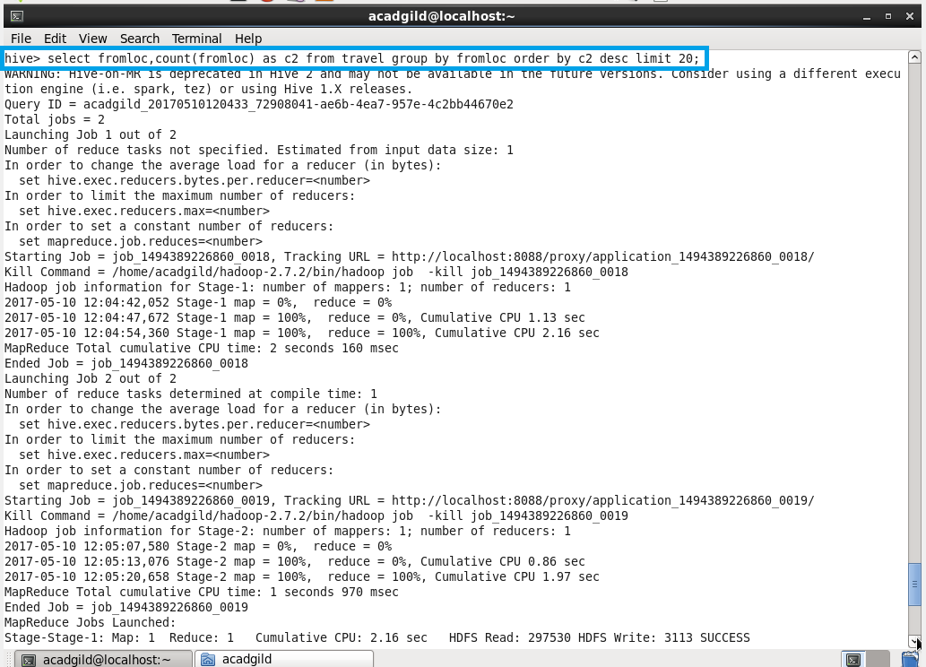

OUTPUT :